# AWS Week 2 Assignments: Cloud Services & AWS Fundamentals

Note: These assignments avoid advanced AWS topics such as CloudFormation, CloudWatch, SNS, SQS, ECS, ECR, and Serverless Architecture. They focus on beginner-friendly, real-world tasks.

## Assignment 1: Launch a Basic EC2 Web Server

Objective: Learn to provision an EC2 instance and host a static website.

1. Steps:
2. Launch a t2.micro EC2 instance with Amazon Linux 2.

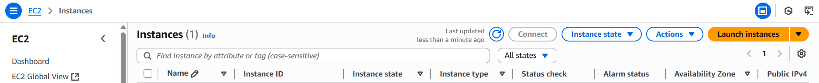

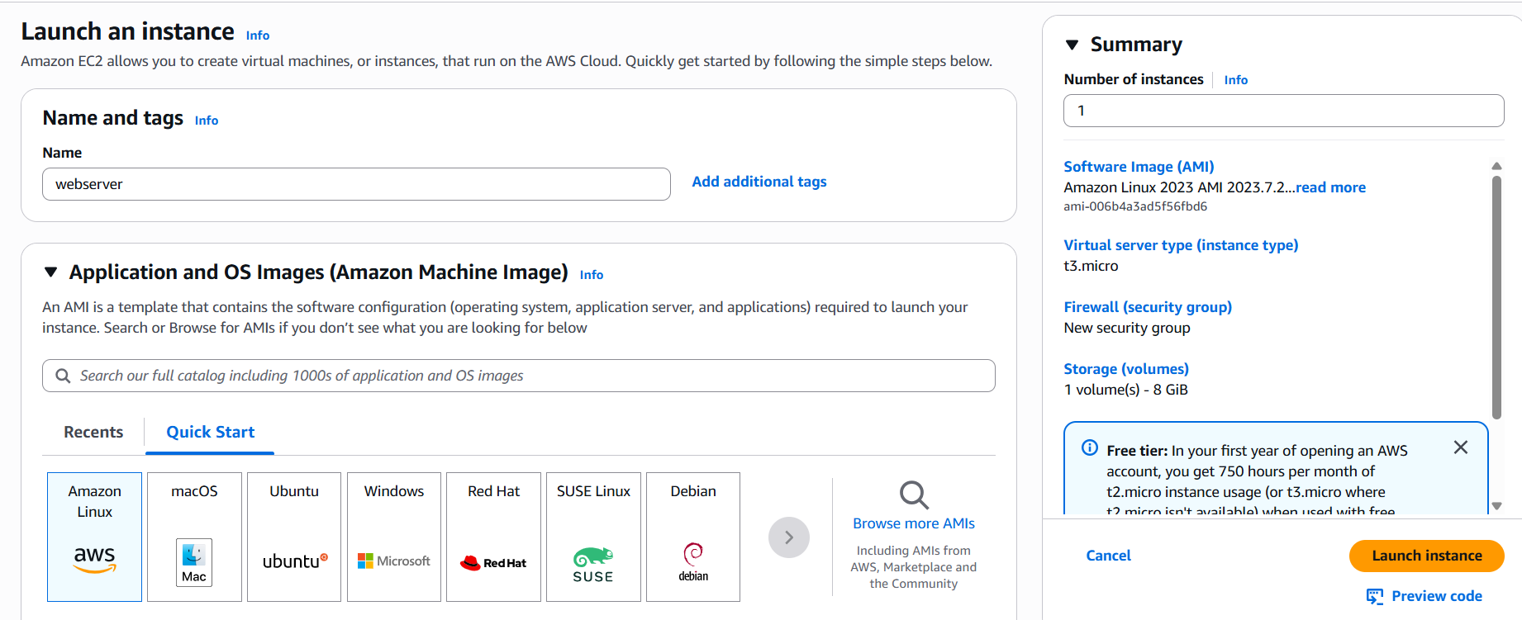





1. SSH into the instance.

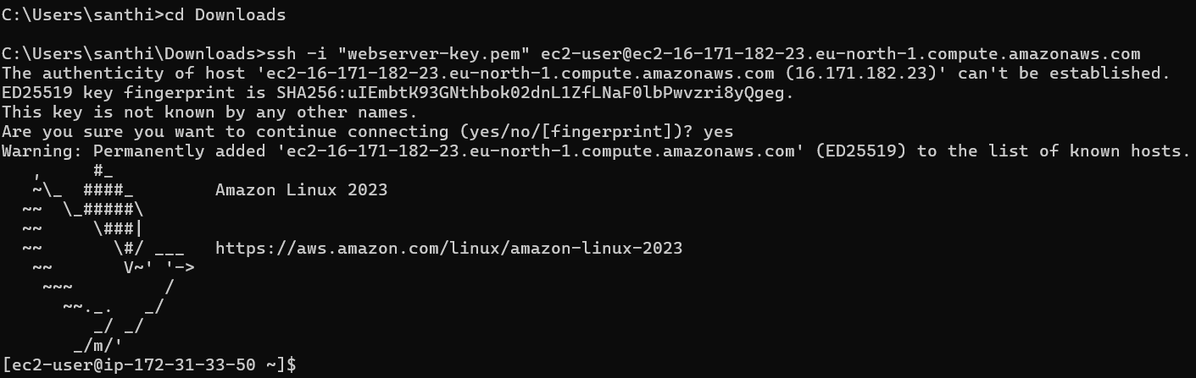

1. Install Apache (sudo yum install httpd -y) and start the service.

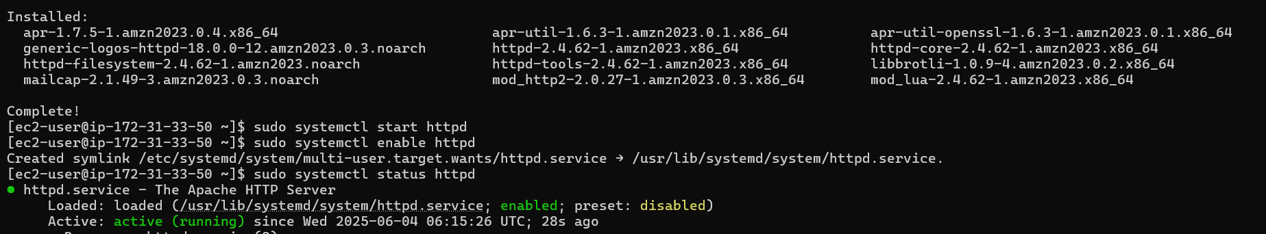

1. Create a basic HTML file (index.html) in /var/www/html/.



1. Access your site using the public IP.

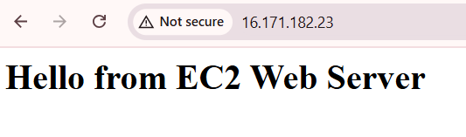

Real-World Value: Simulates setting up a basic server for testing or portfolio hosting.

## Assignment 2: Configure Security Groups for Controlled Access

Objective: Learn security basics by restricting EC2 access.

1. Steps:

1. Create two security groups:  
 - SG-HTTP: Allow inbound HTTP (port 80) from anywhere.

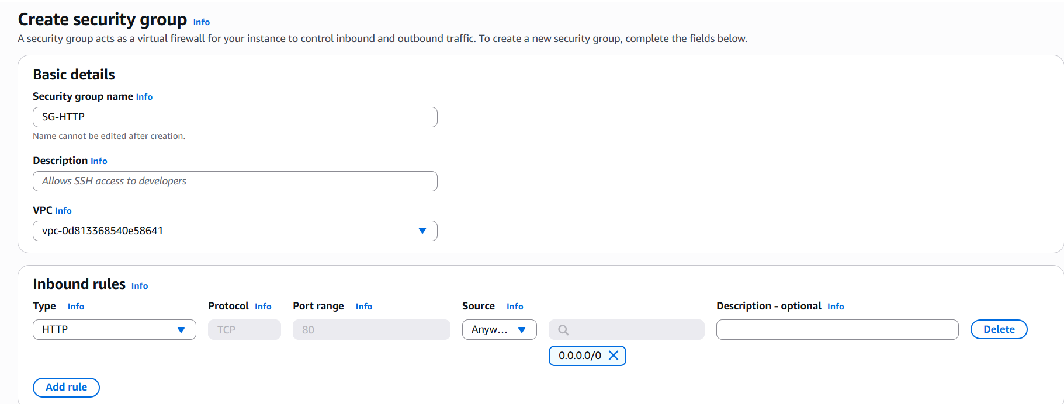

- SG-SSH-MyIP: Allow SSH (port 22) only from your IP.

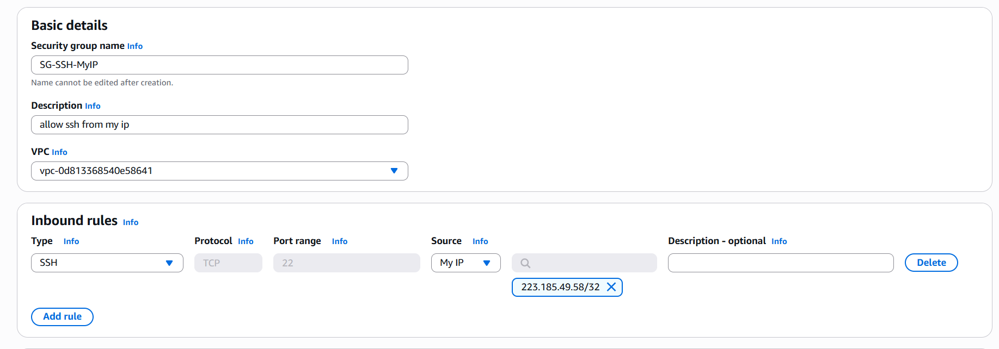

1. Attach these to your EC2 instance.

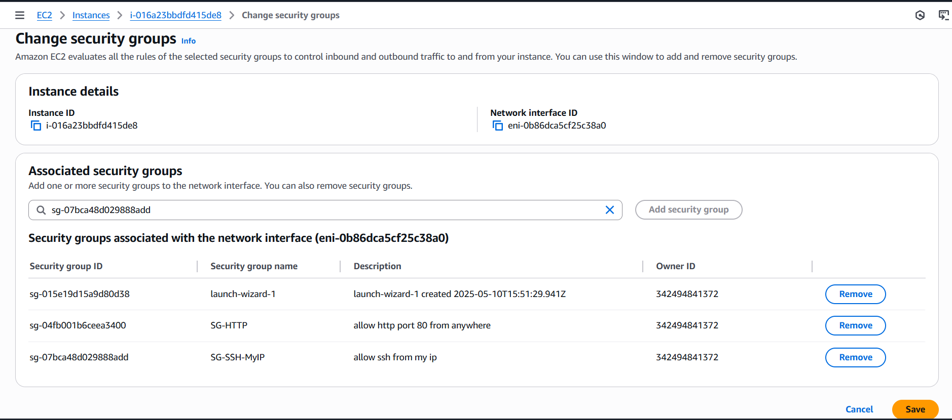

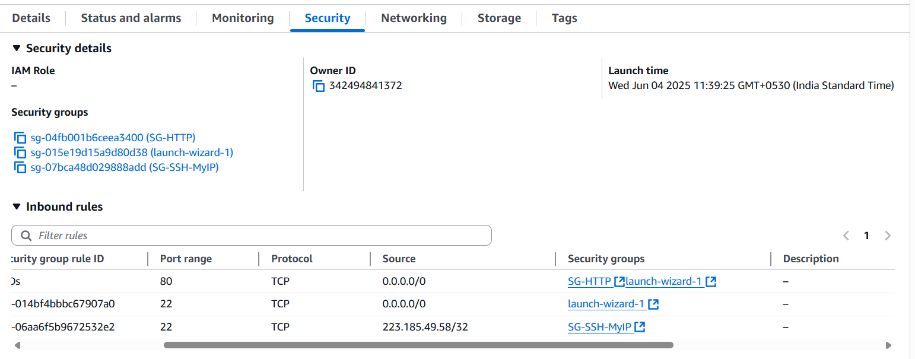

Real-World Value: Demonstrates safe practices for server access.

## Assignment 3: Explore S3 for Static File Hosting

Objective: Use S3 to host a static site or image gallery.

1. Steps:
2. Create a new S3 bucket.

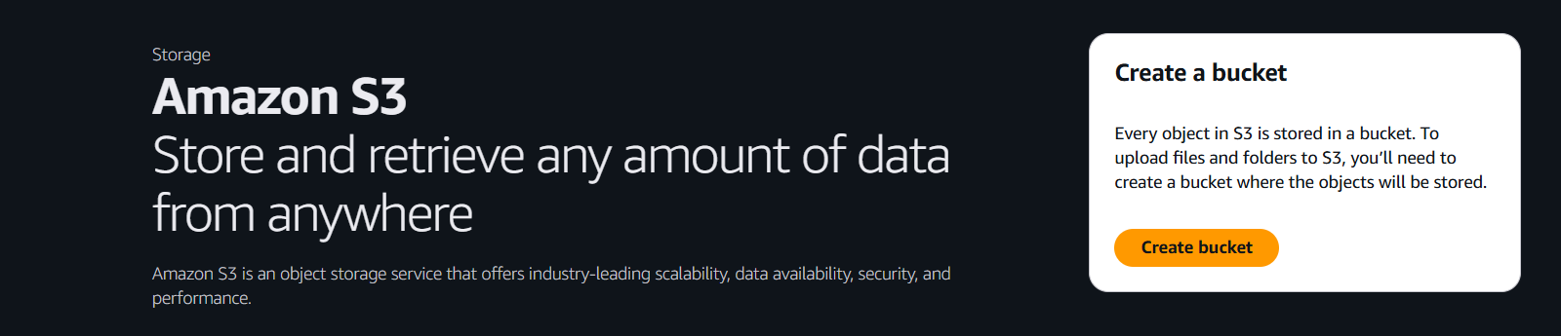

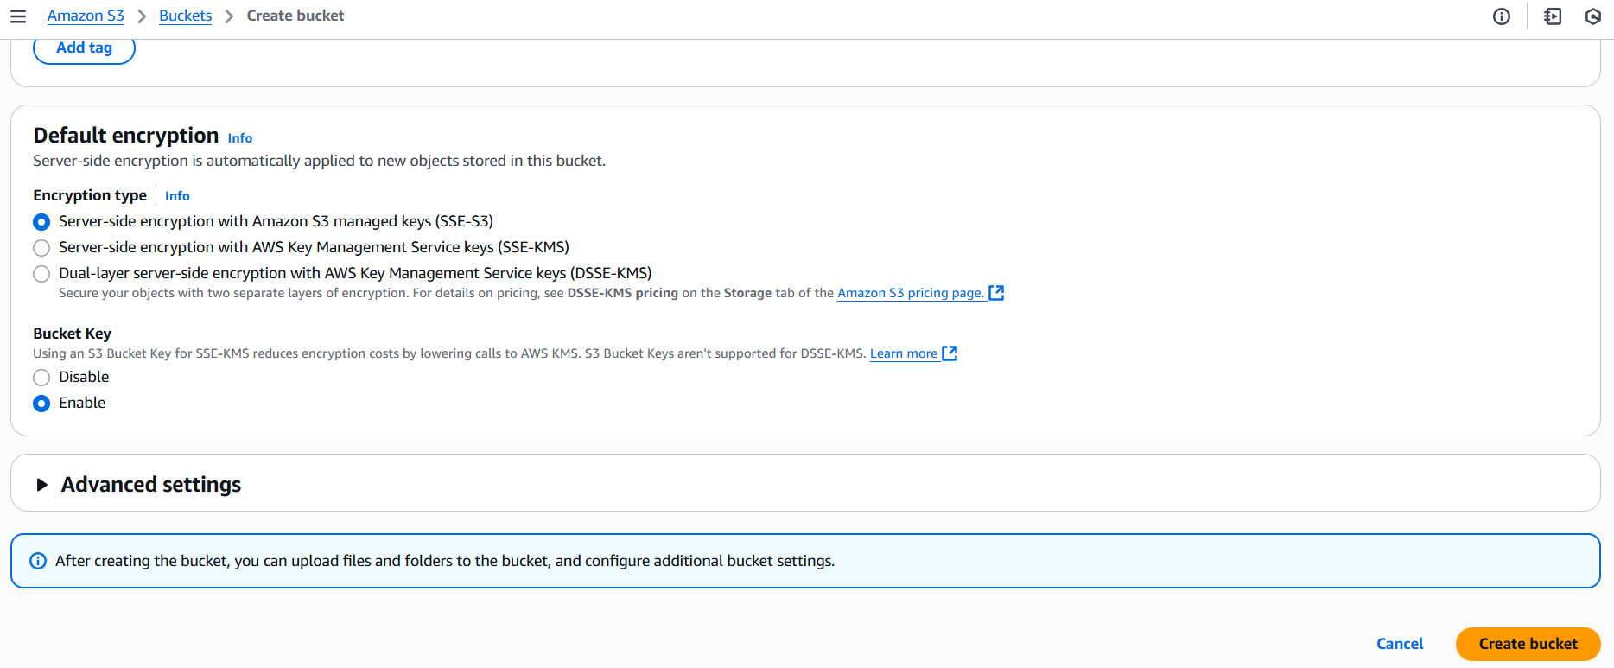

1. Enable static website hosting.

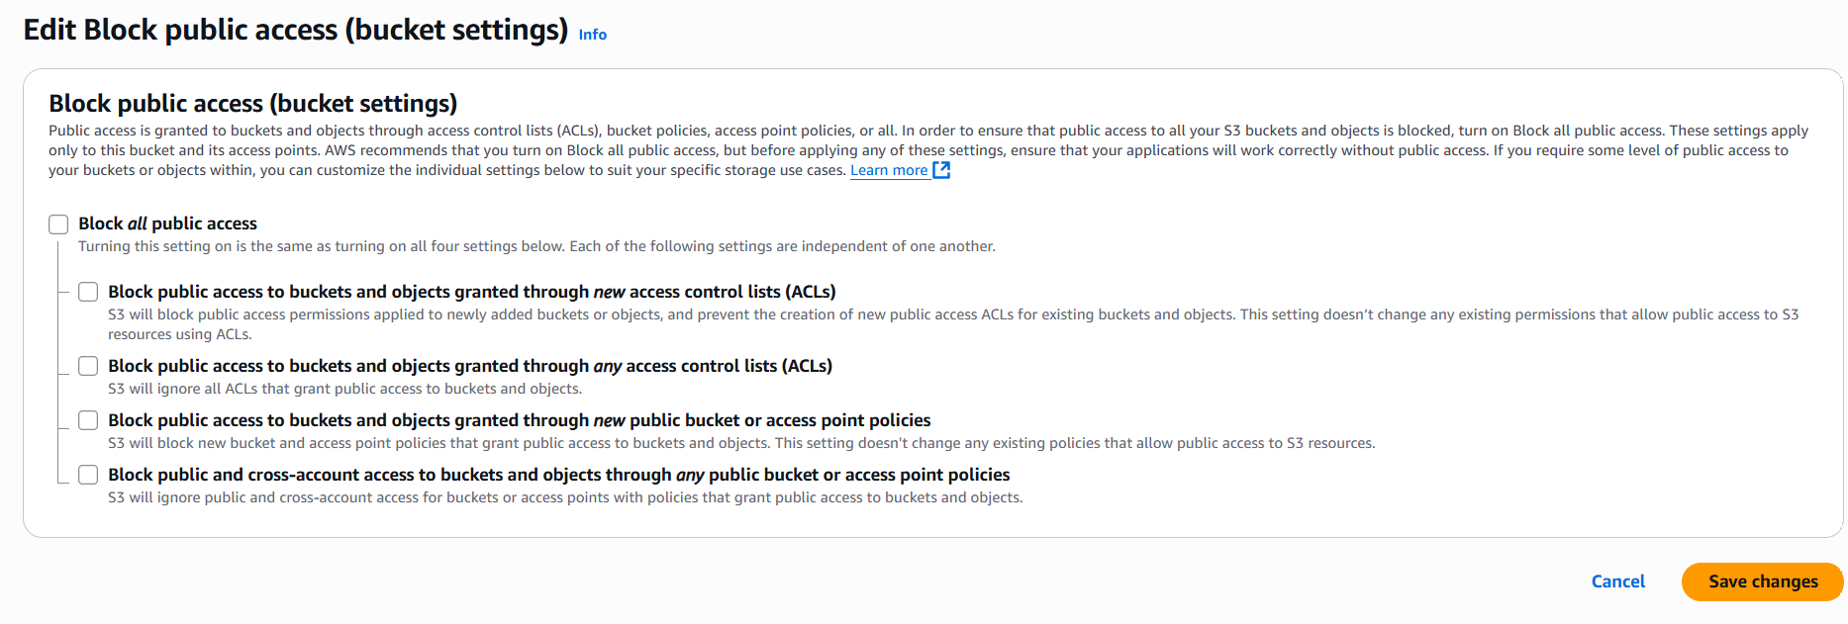

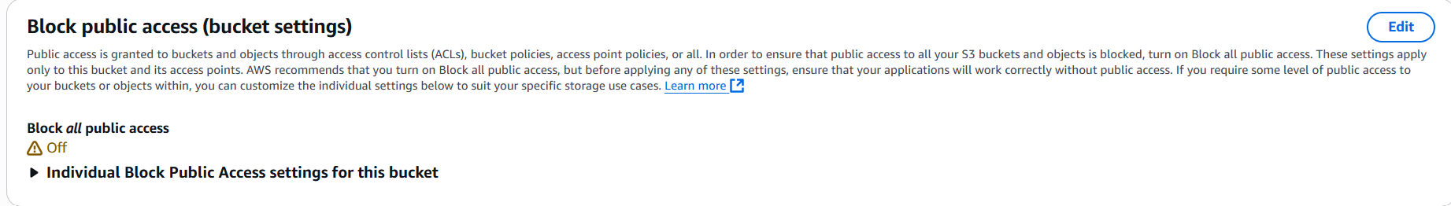

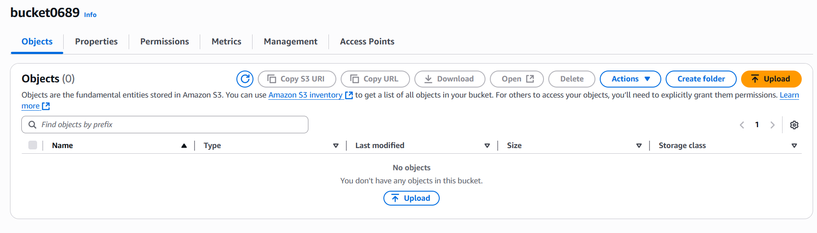



1. Upload an HTML file and some images.

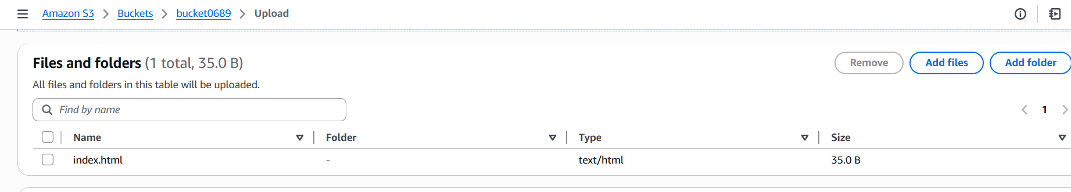

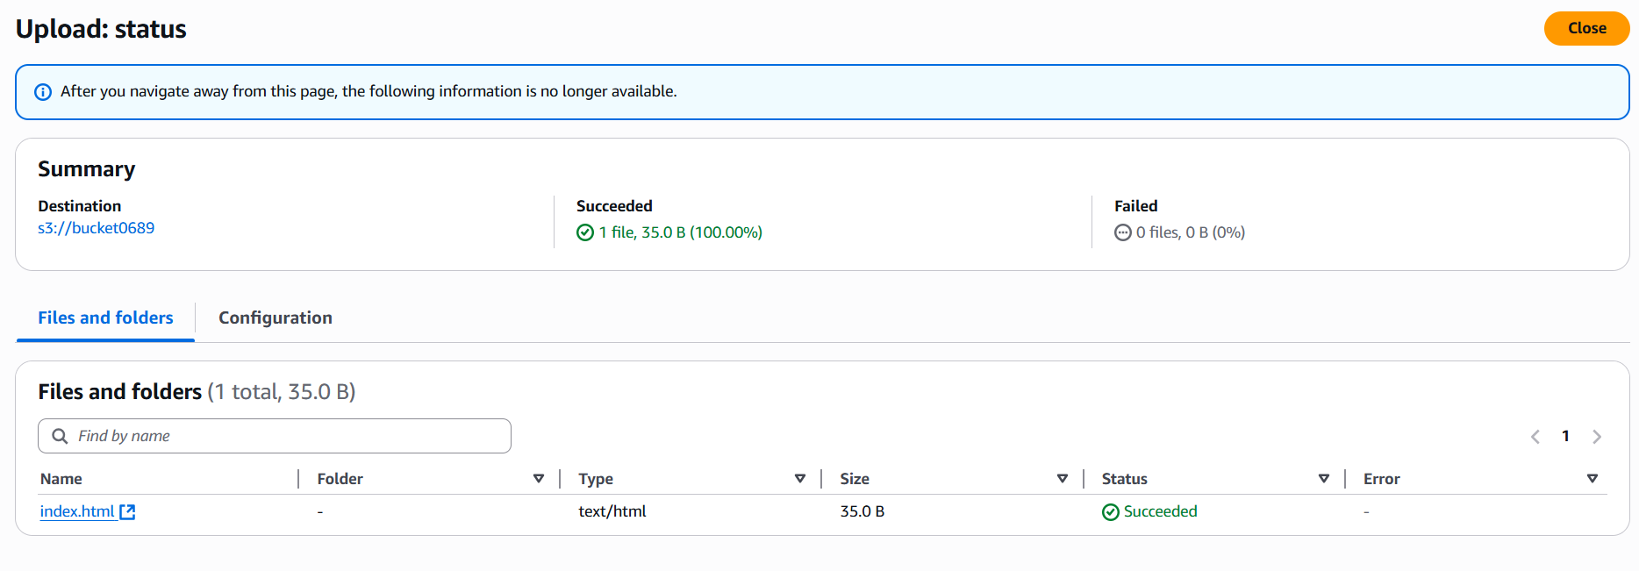

1. Set proper permissions for public access.

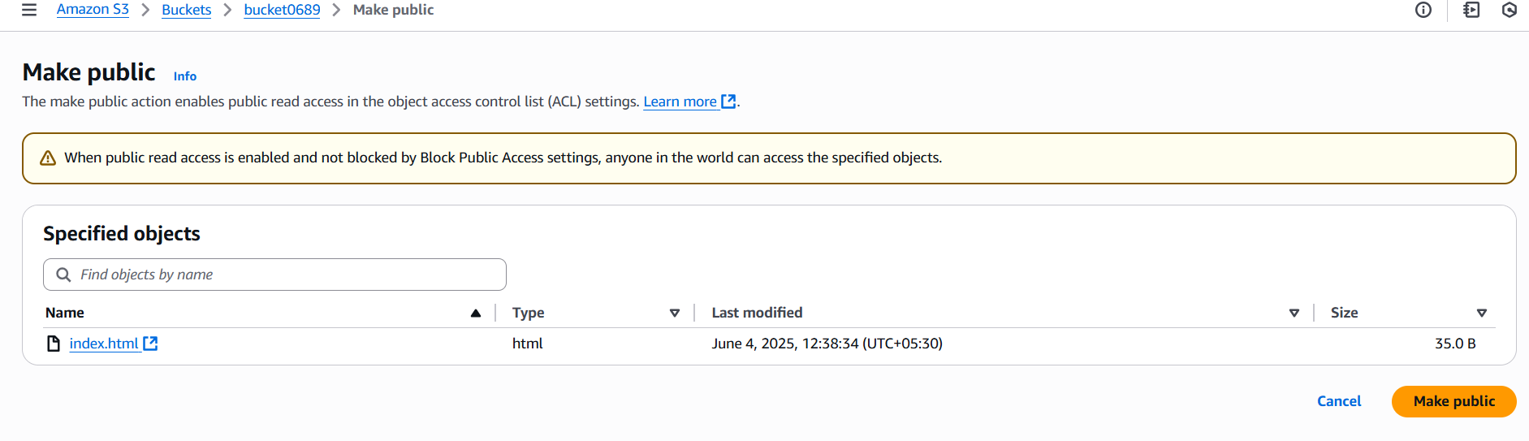

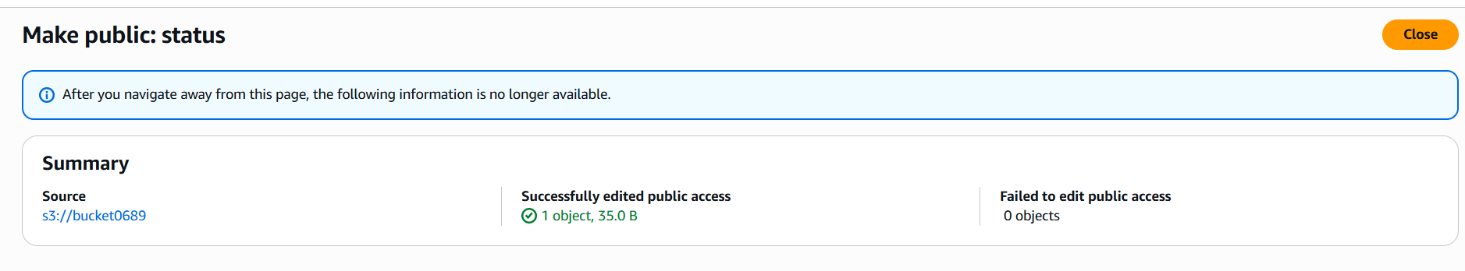

Enable static website hosting

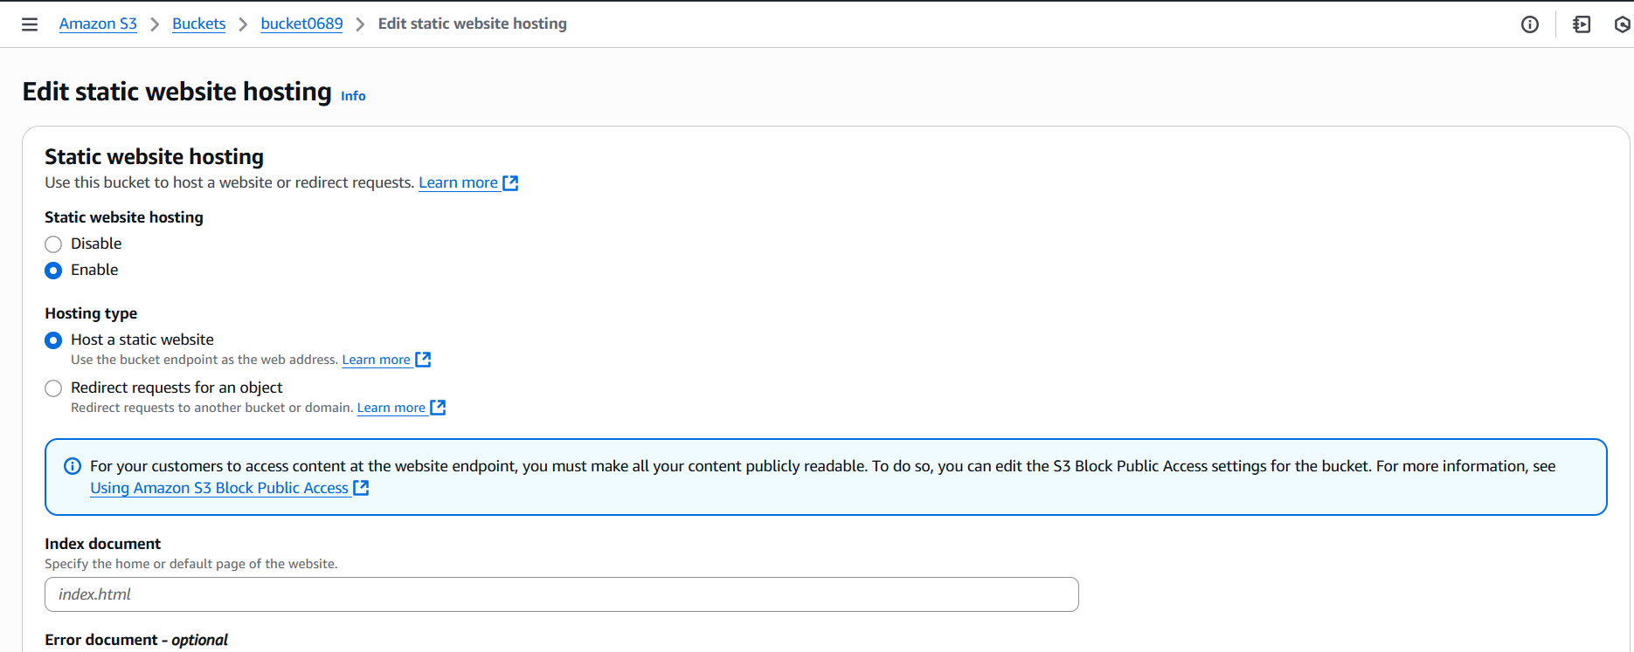

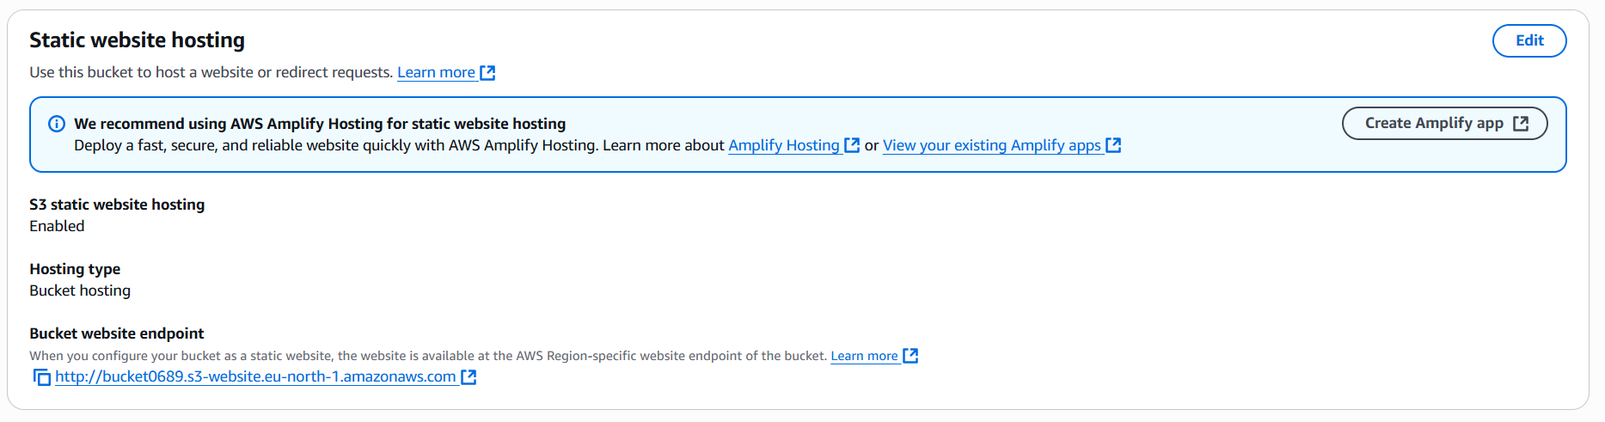

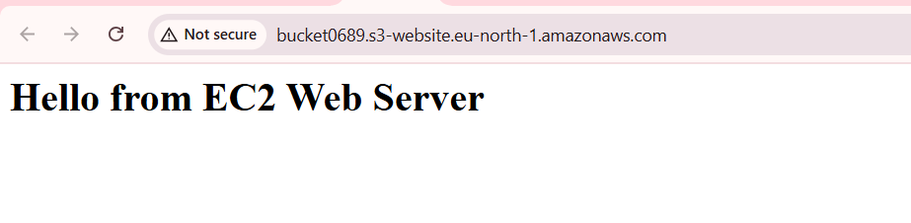

Real-World Value: Useful for hosting resumes, landing pages, or portfolios.

## Assignment 4: Simulate a Scalable Environment

Objective: Understand Auto Scaling Groups (ASG) and Load Balancers.

1. Steps:
2. Create a Launch Template for EC2.

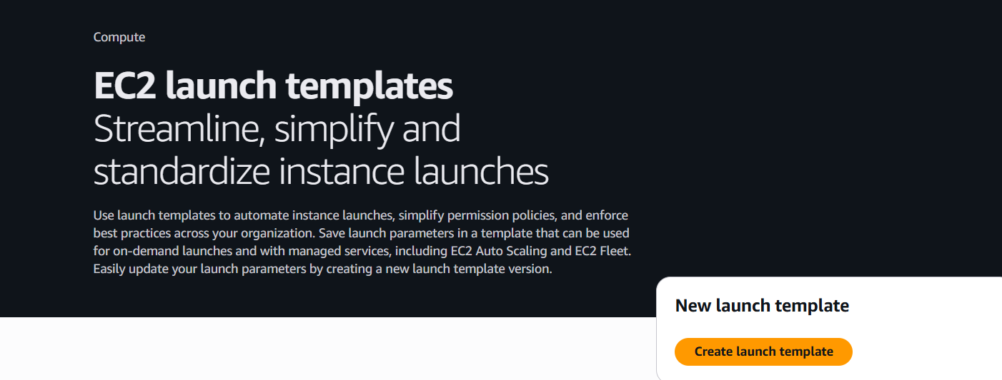

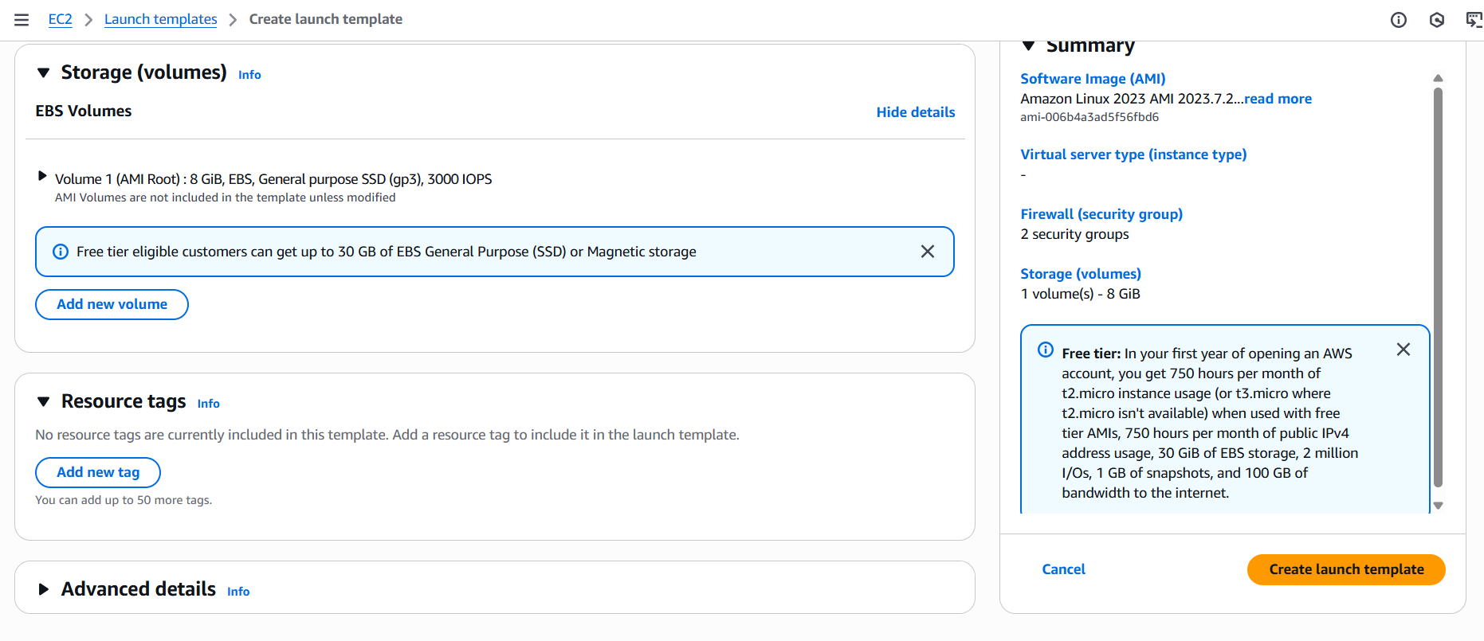

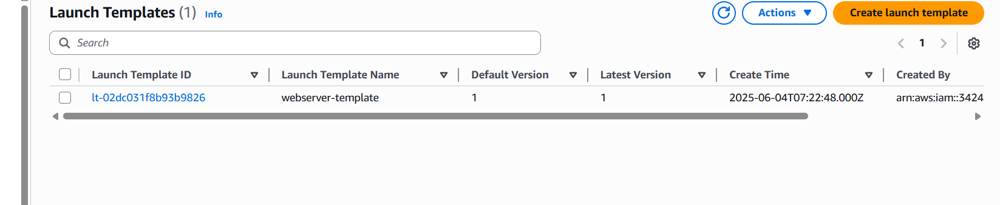

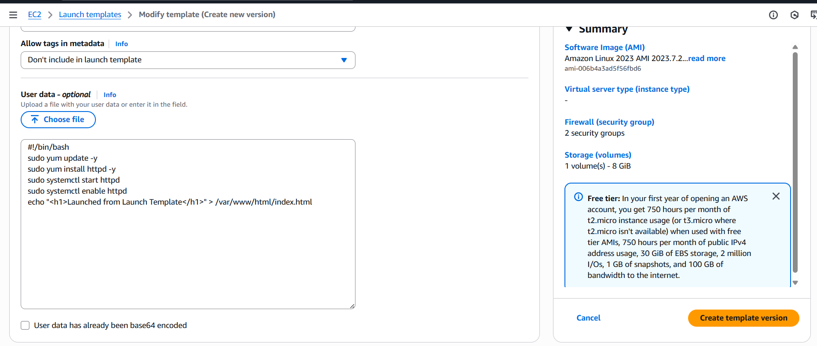

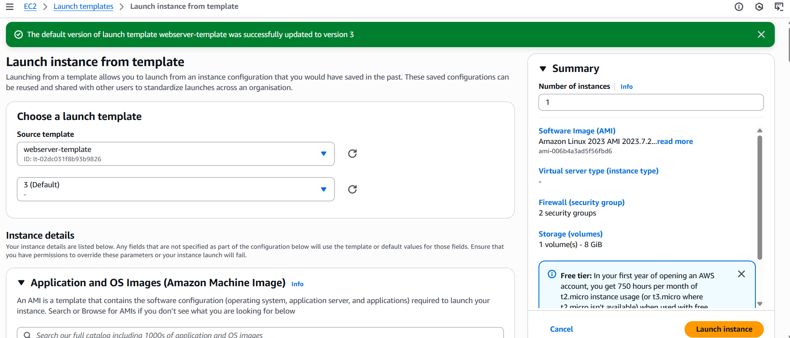

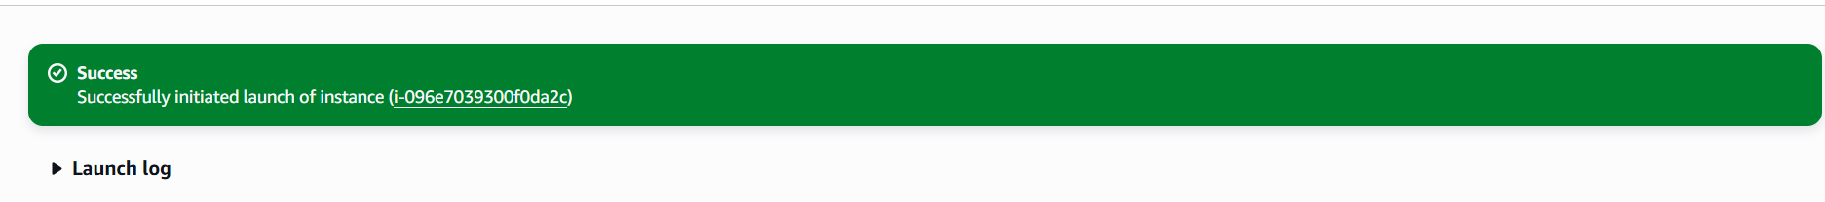

1. Configure an Auto Scaling Group using the template.

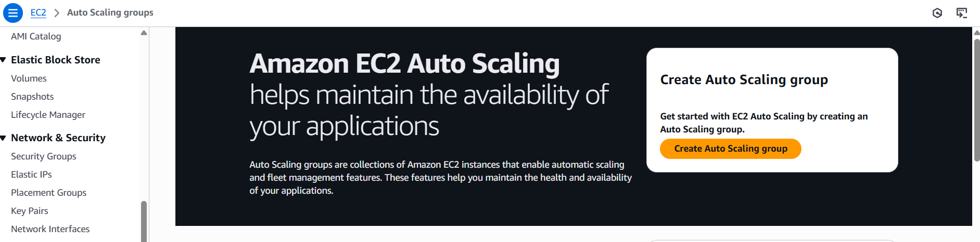

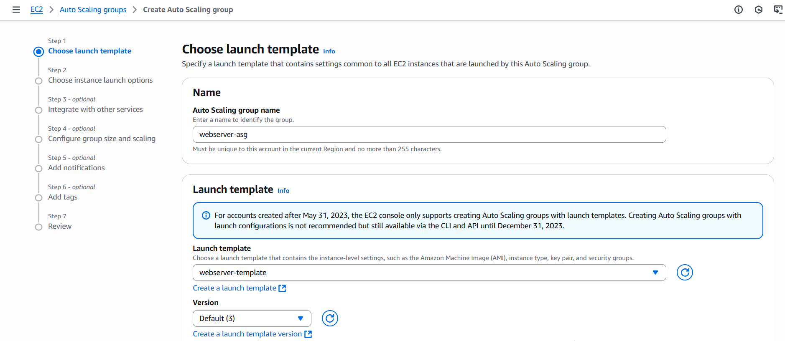

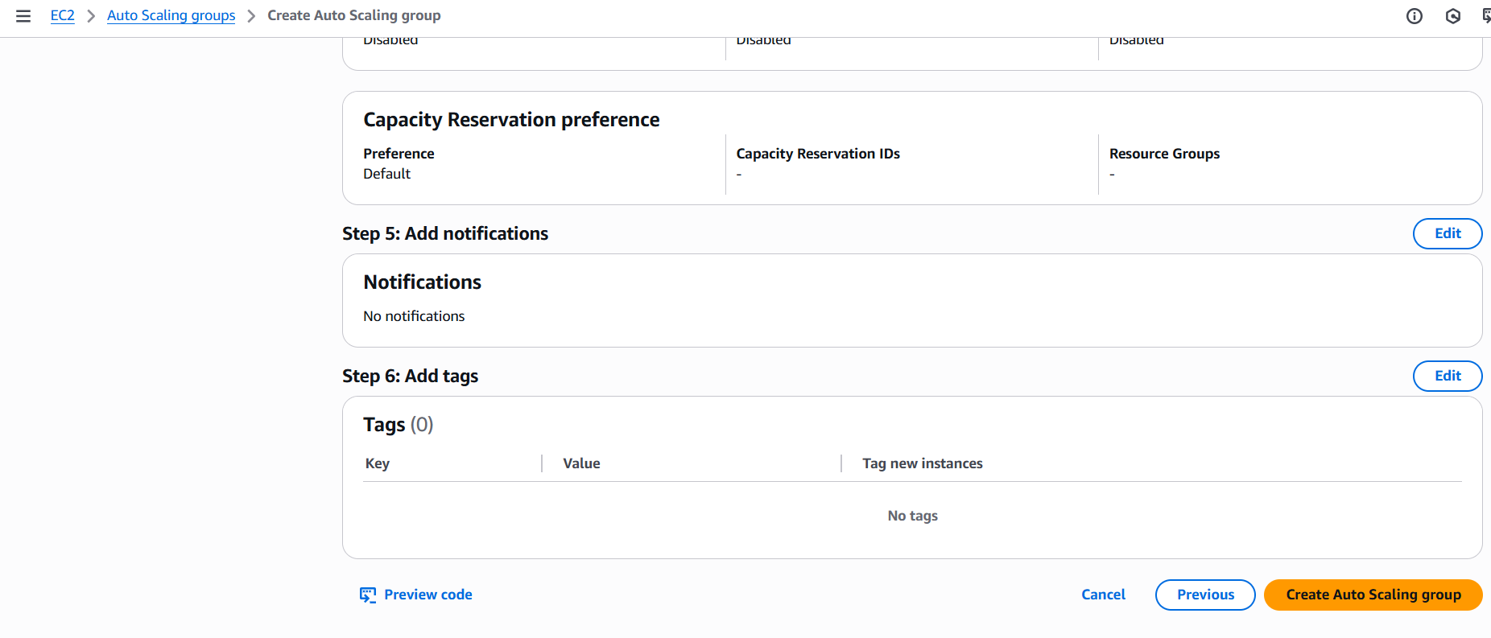

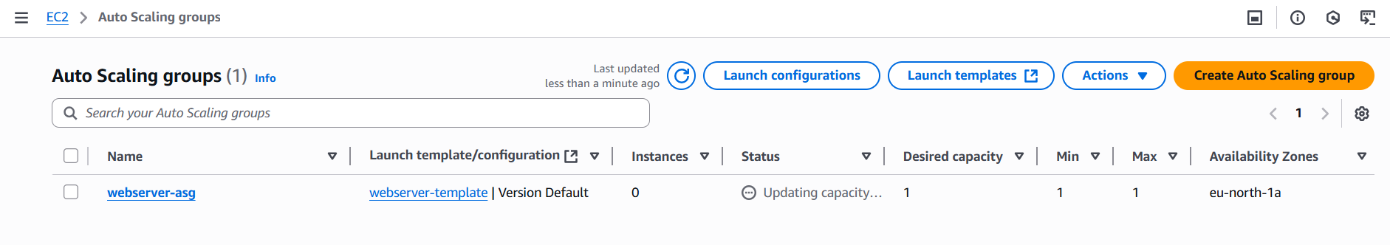

1. Attach a Load Balancer to distribute traffic.

Create a target group

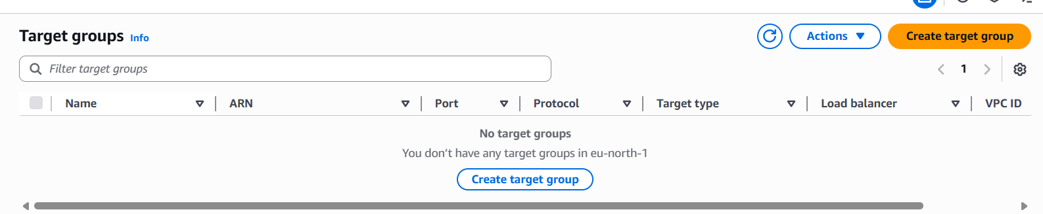

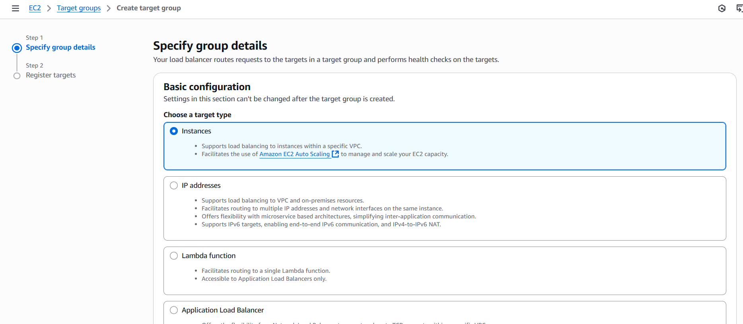

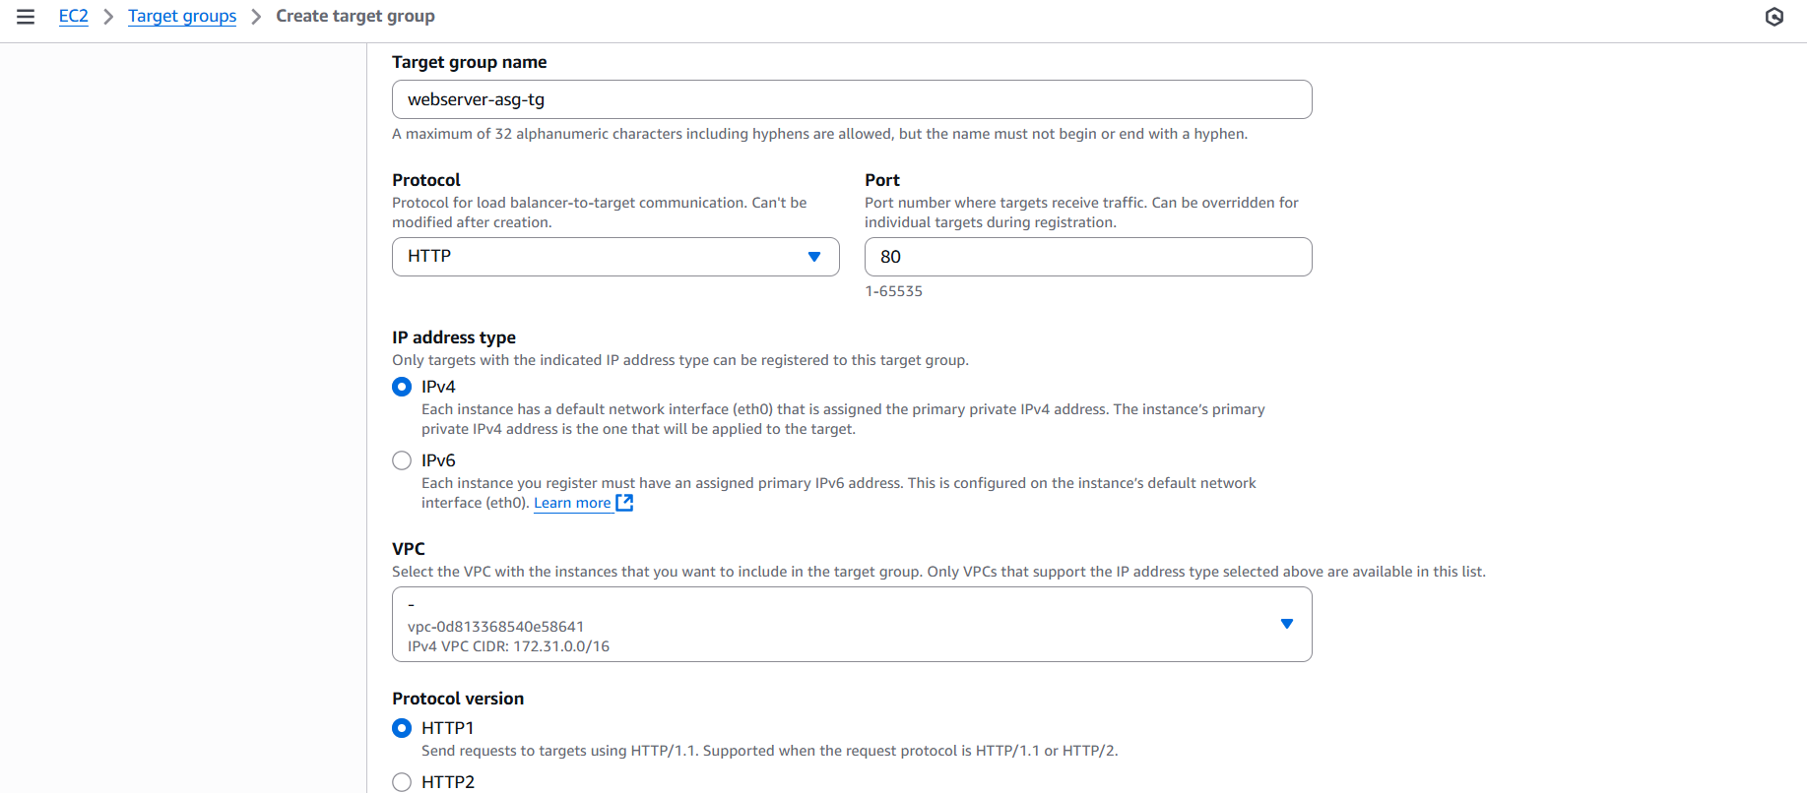

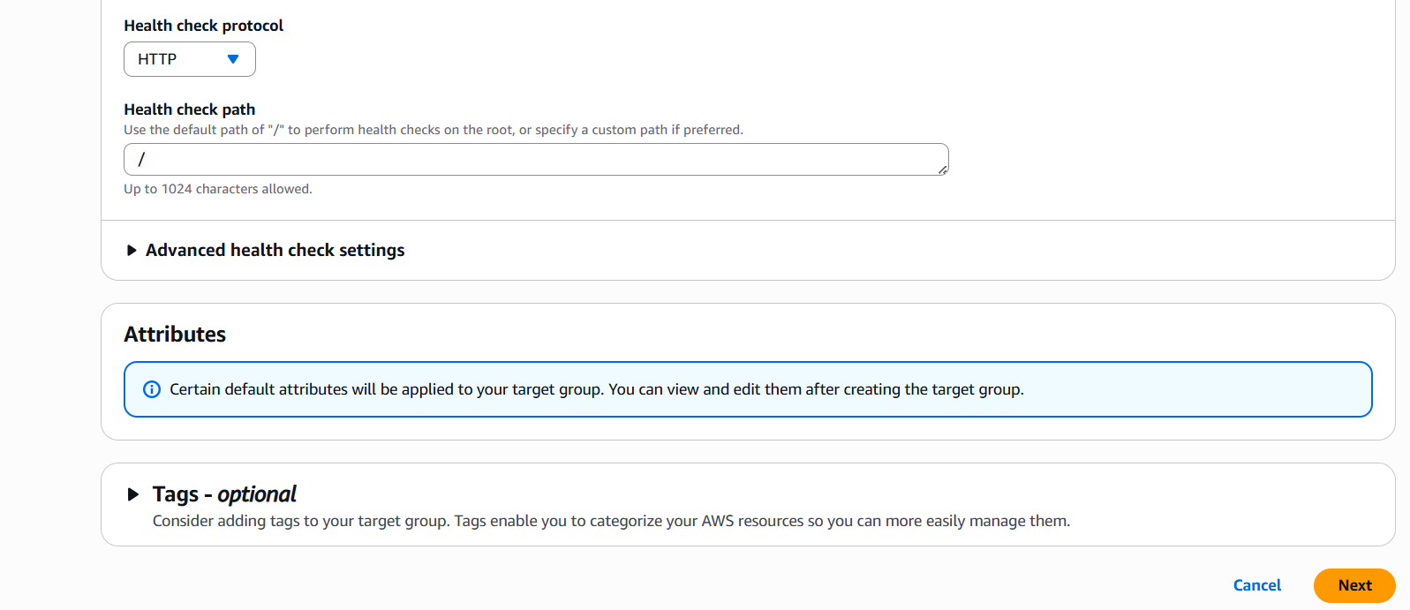

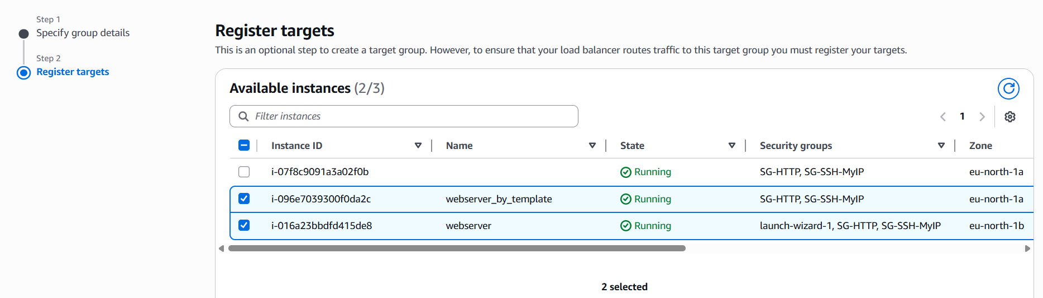

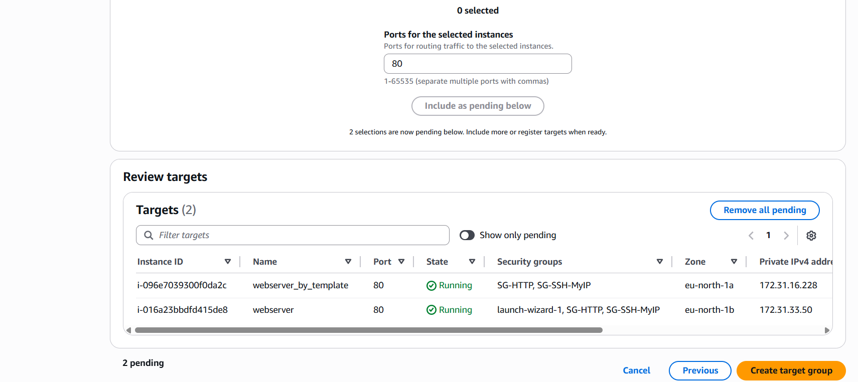

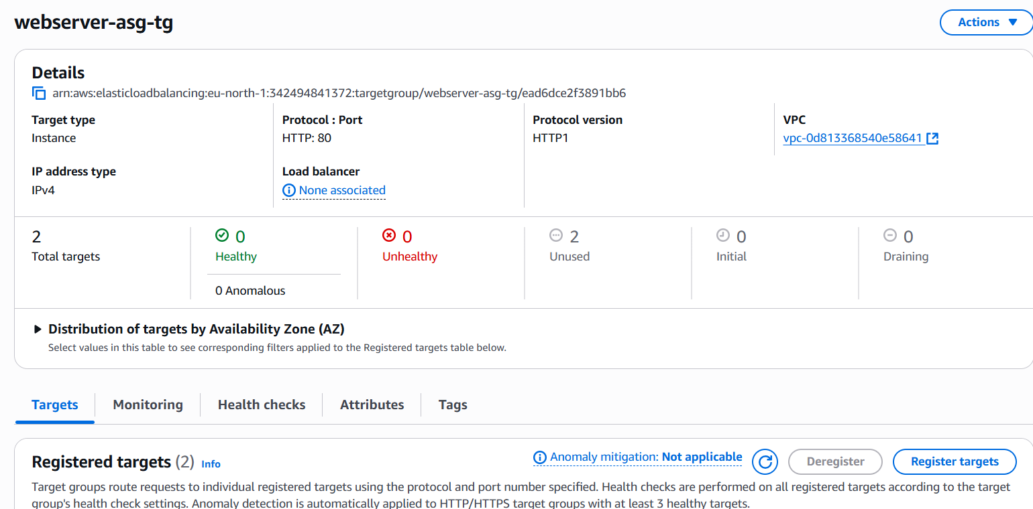

Create load balancer

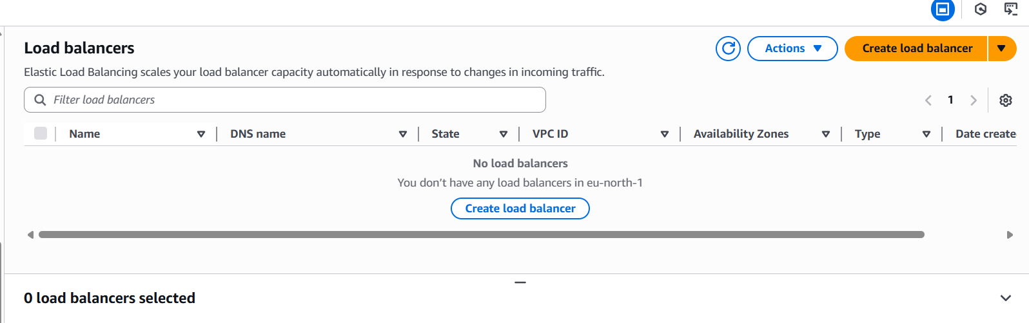

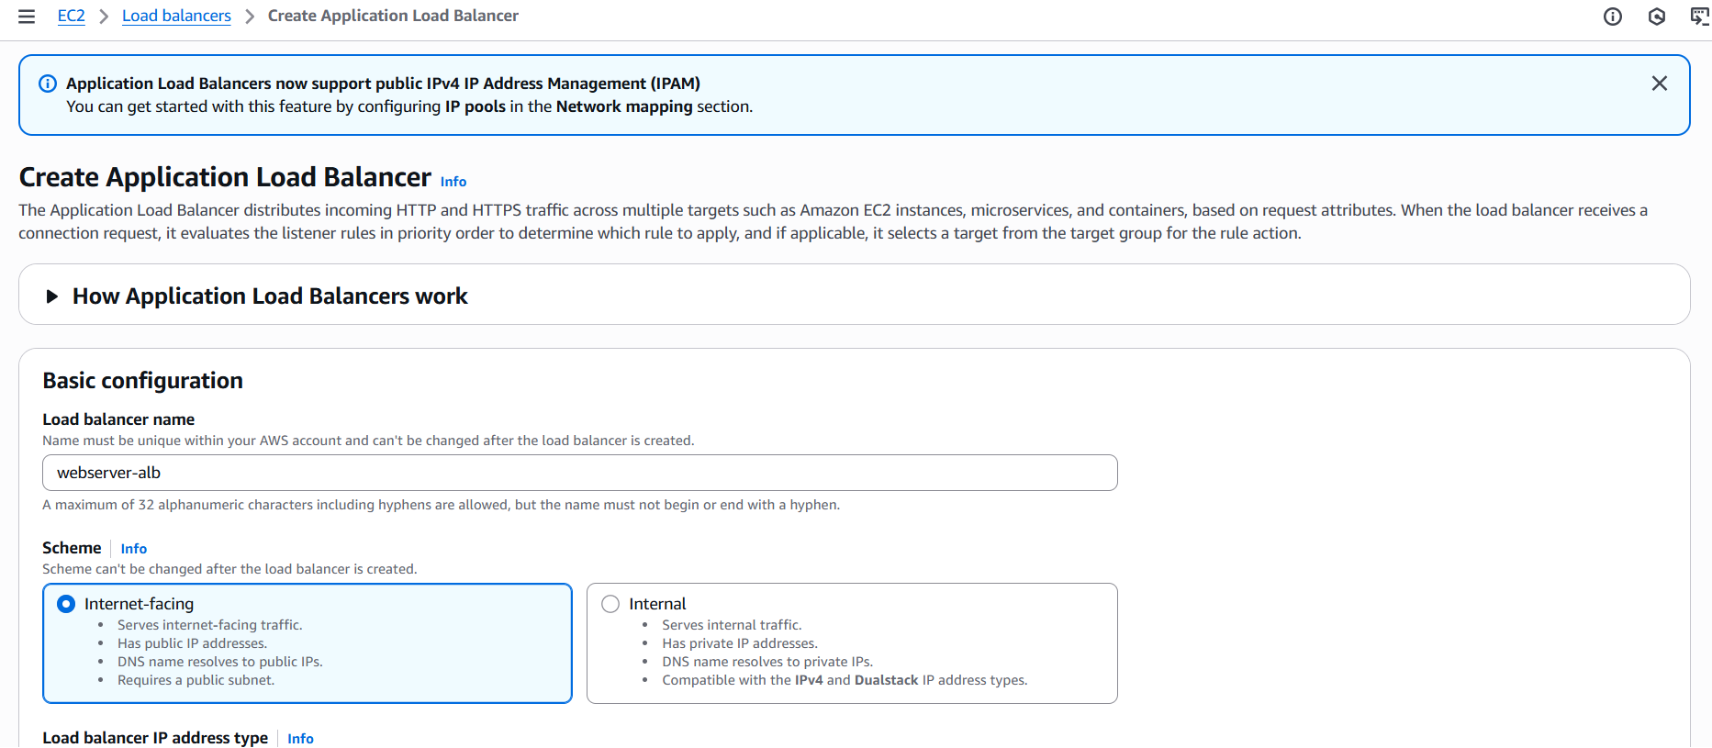

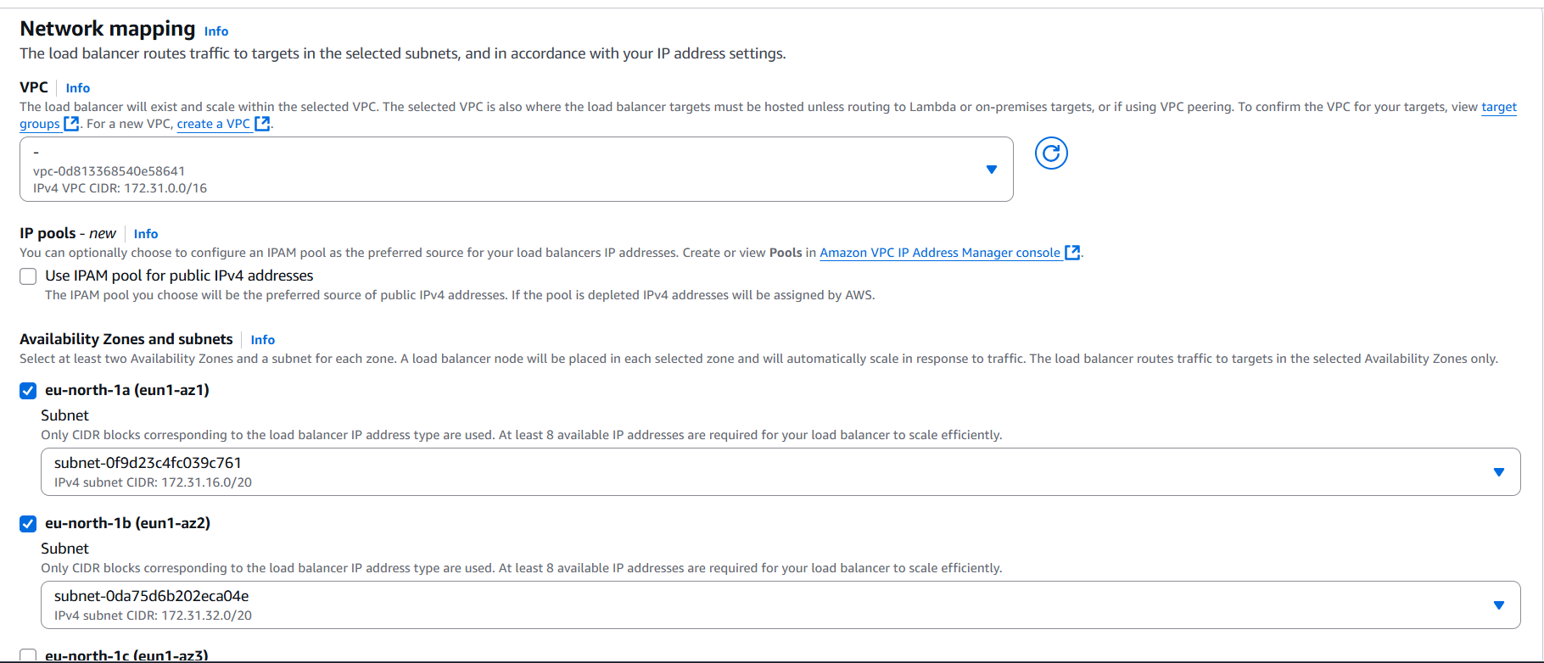

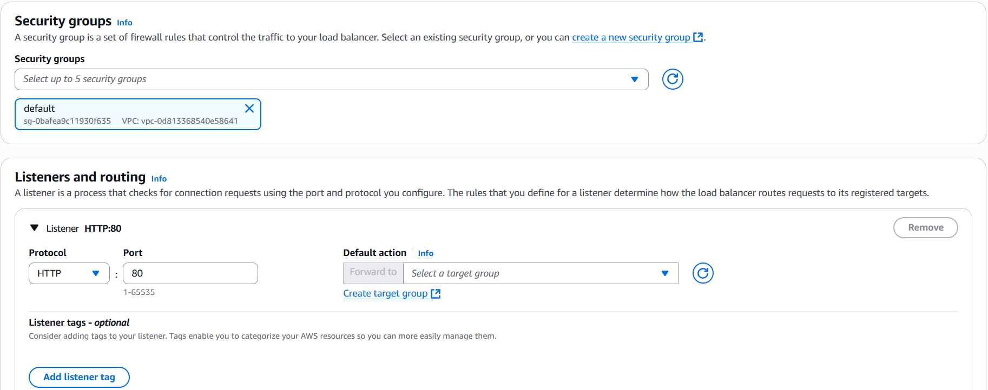

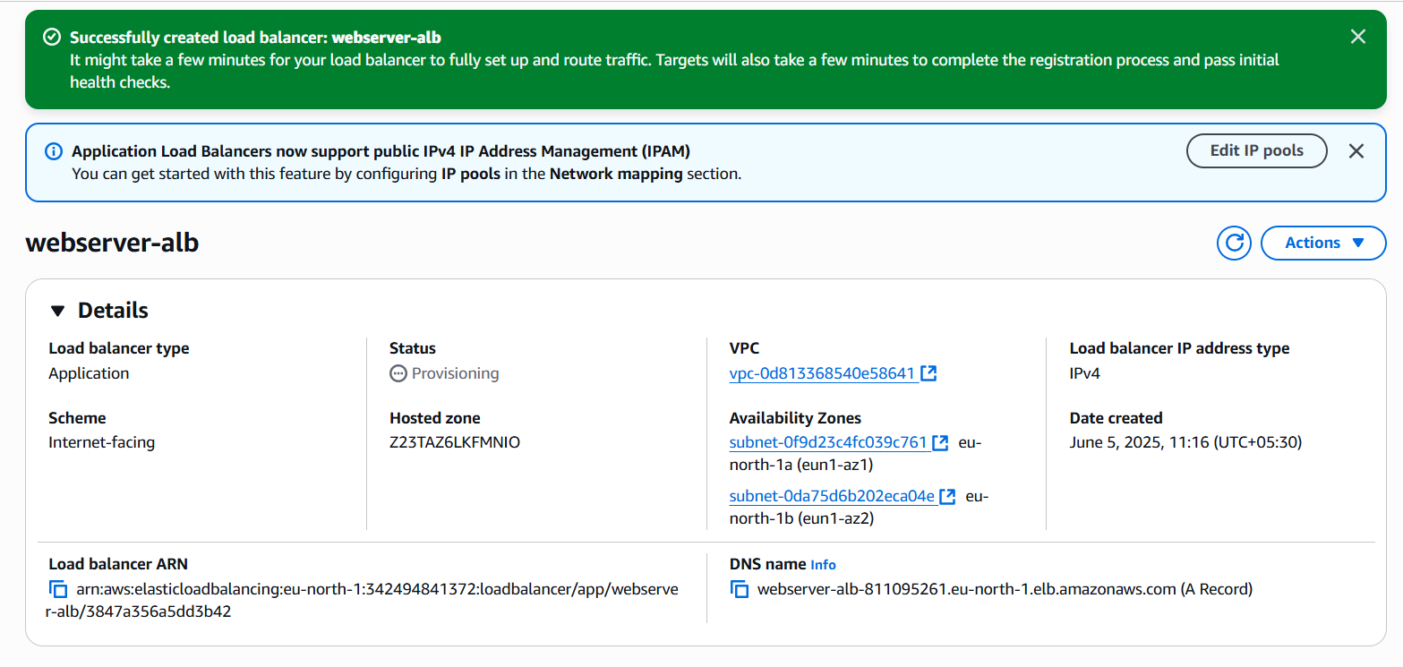

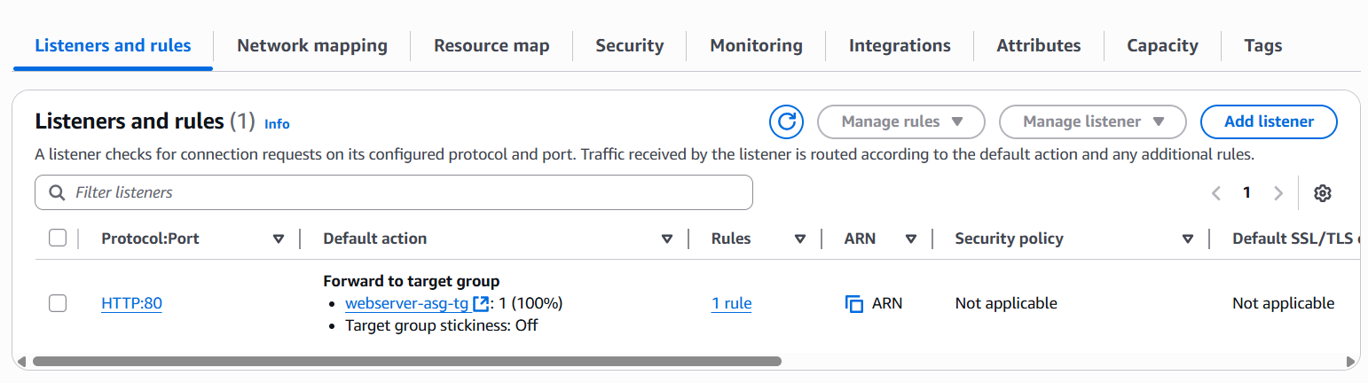

Attach Load balancer to auto scaling group

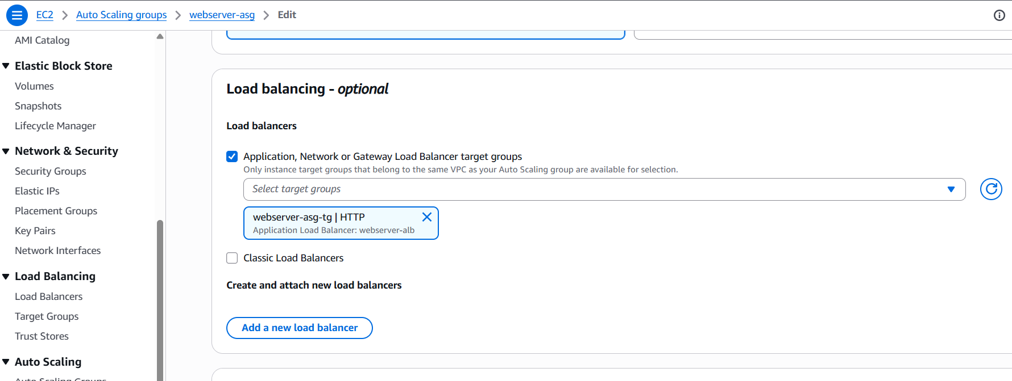

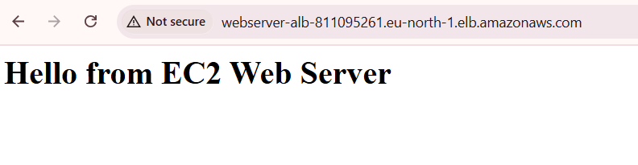



Real-World Value: Mimics real-world backend scalability.

## Assignment 5: IAM Roles and Policies

Objective: Apply identity and permission management.

1. Steps:
2. Create a new IAM role with AmazonS3ReadOnlyAccess.

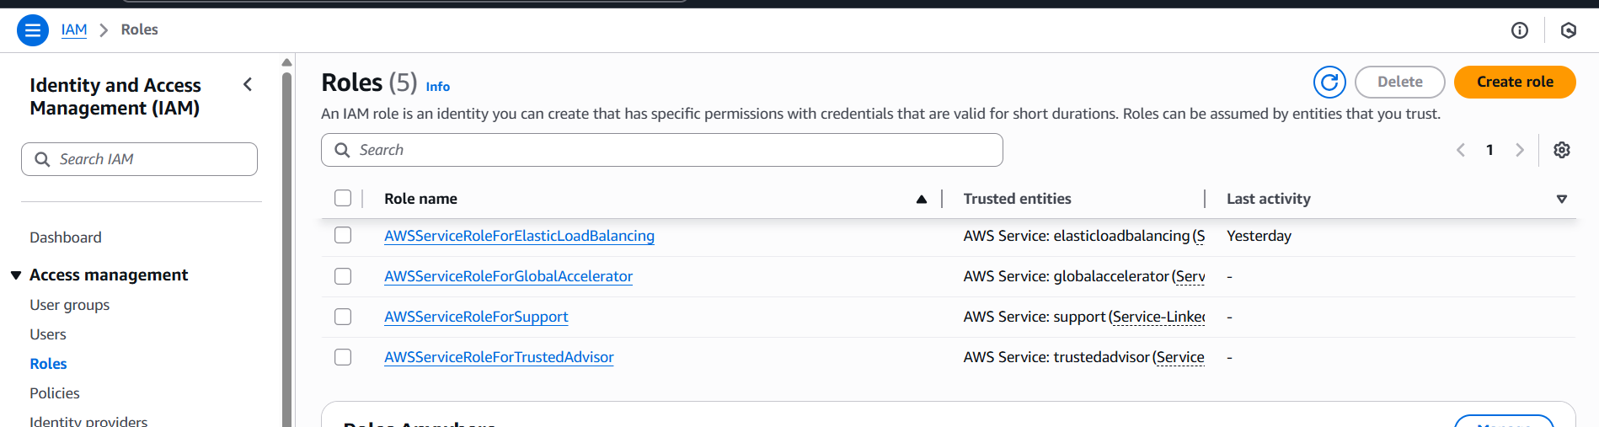

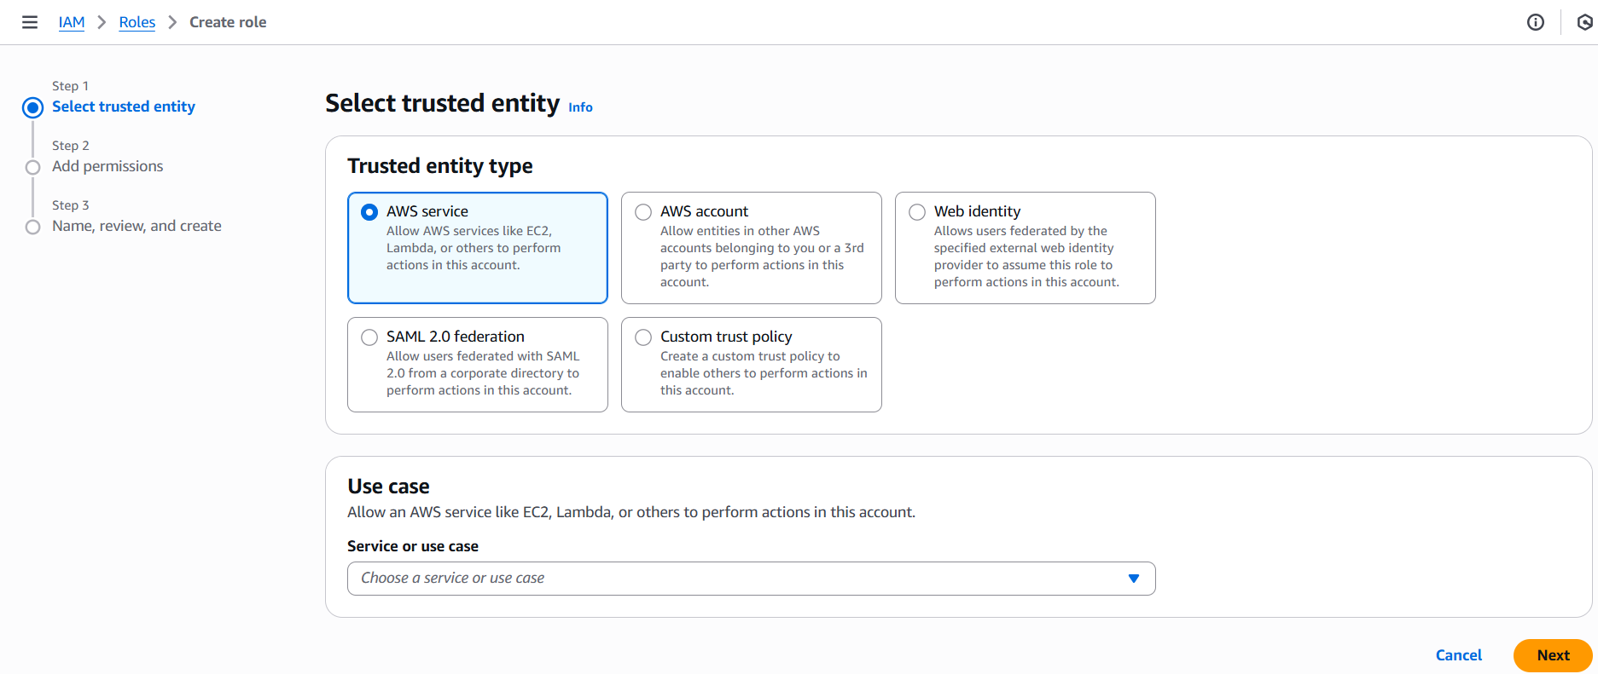

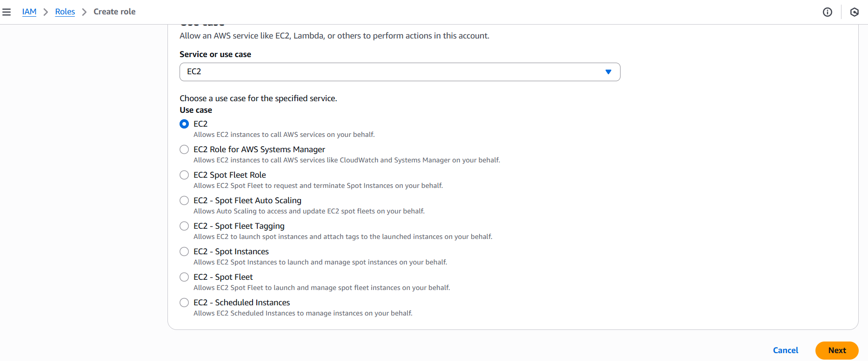

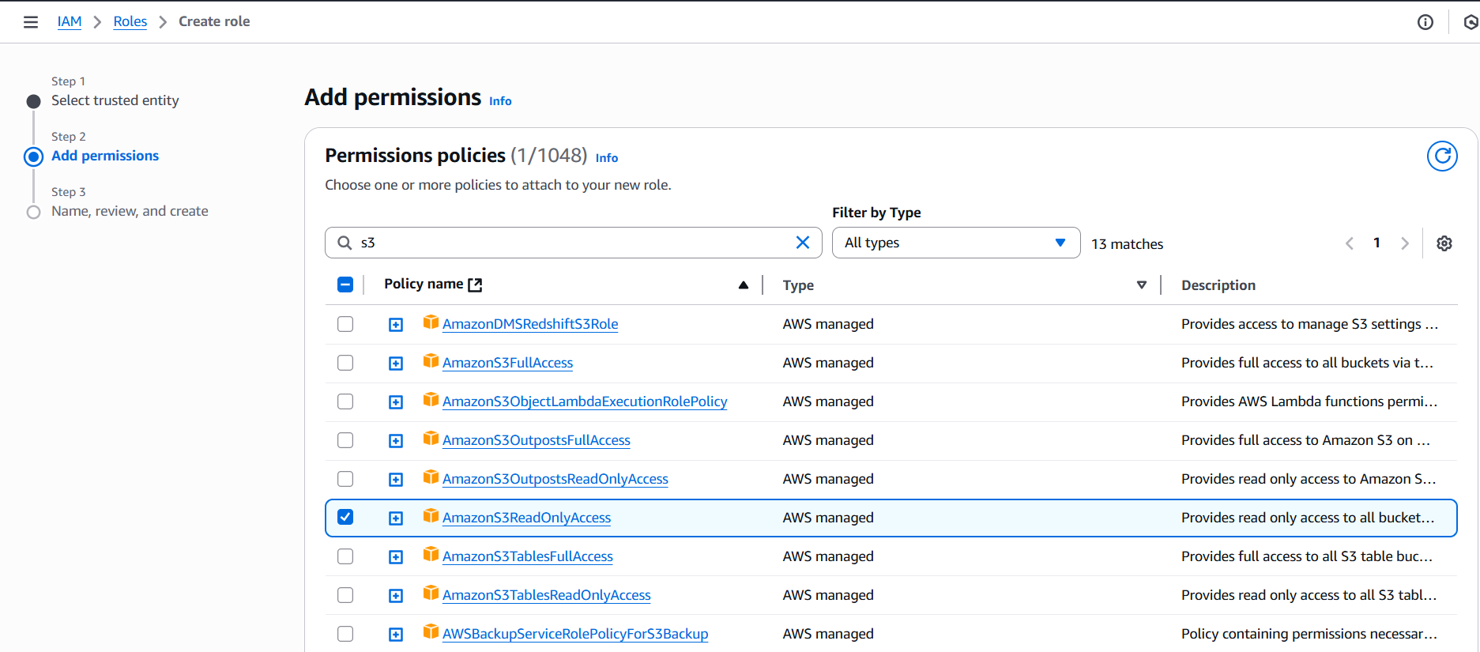

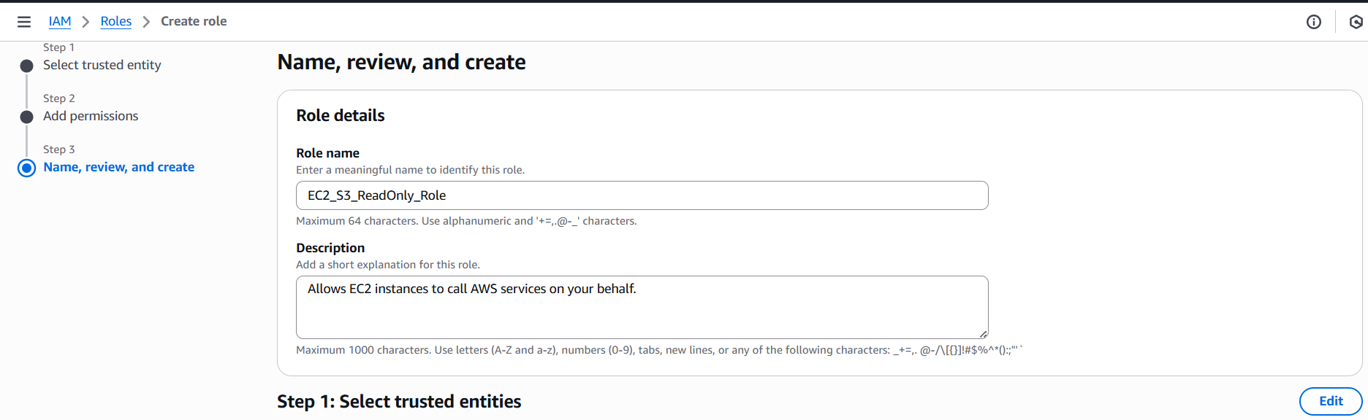

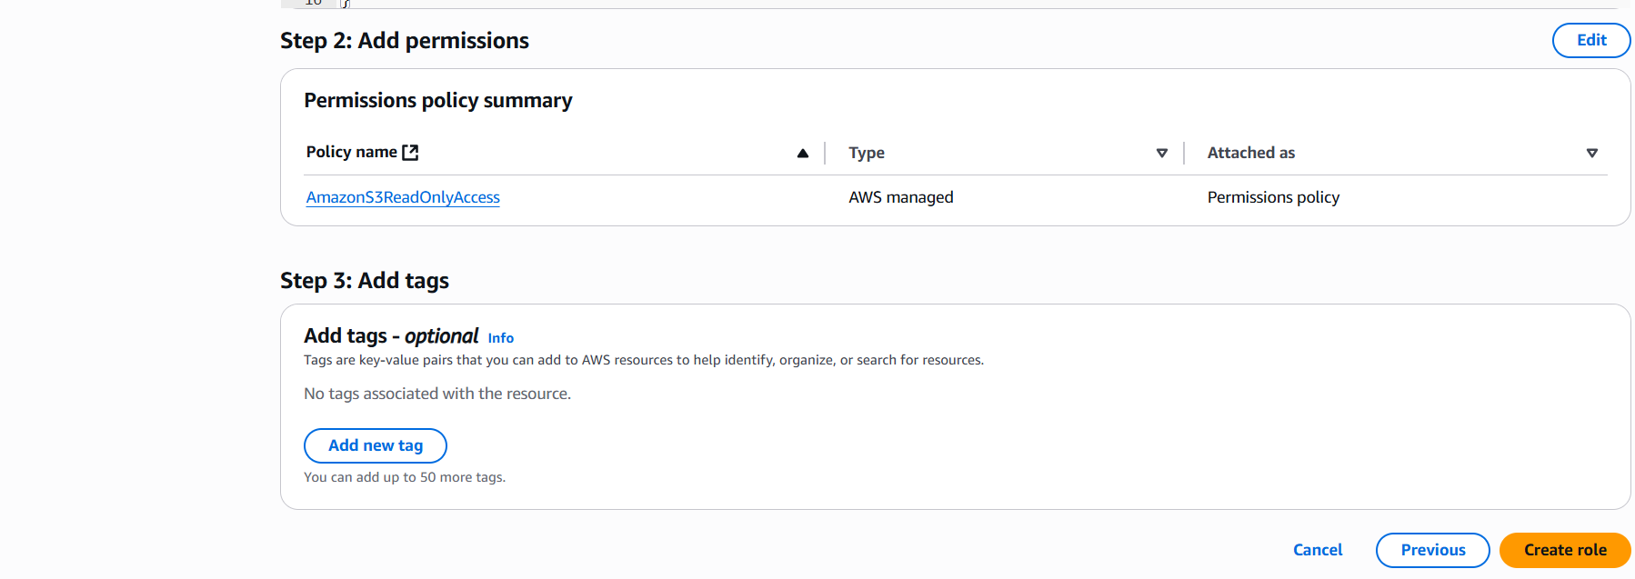

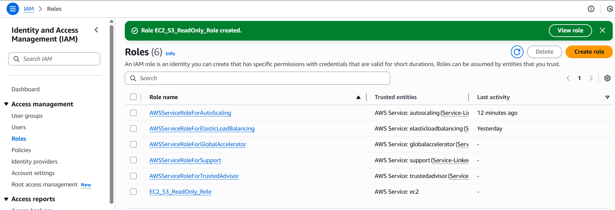

1. Attach it to an EC2 instance.

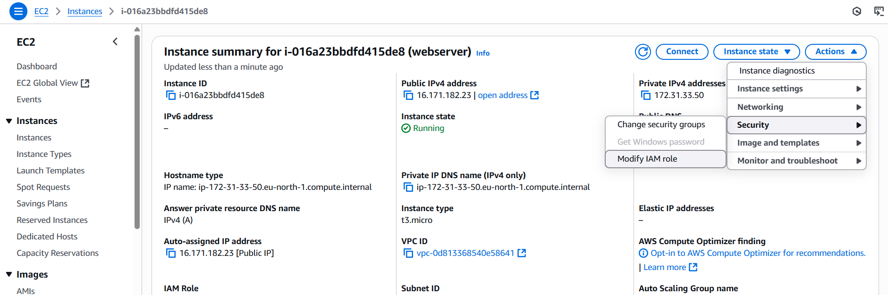

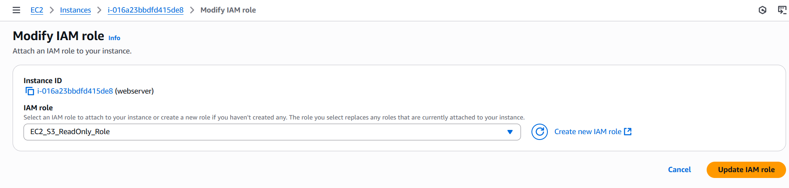

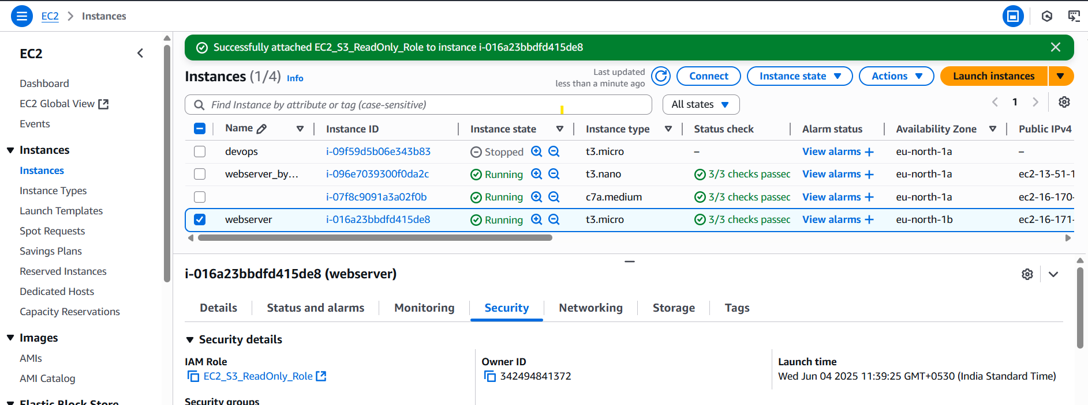

1. Use the instance to list S3 bucket contents via the AWS CLI.

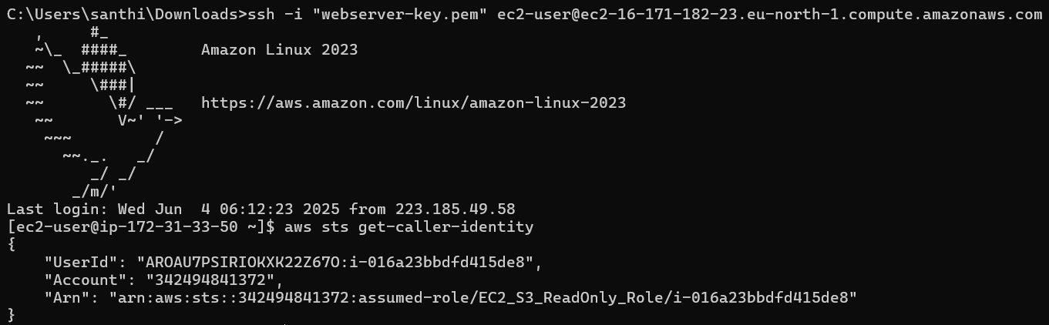

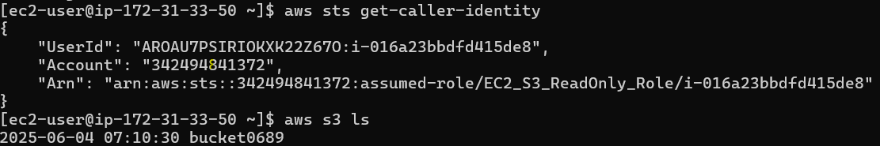



Real-World Value: Teaches principle of least privilege and AWS identity handling.